
Faculty of Engineering and Technology
Electrical and Computer Engineering Department

INTERFACING TECHNIQUES
ENCS4380

Task 2: 3D printing Robot

Prepared by: ID’s: section:
Mohammadkhair Awwad 1220166 2
Ibrahim Salahat 1221701 1
Manar Zitawi 1221806 1
Ruba Aldaghamin 1220925 2

Instructor: Wasel Ghanem

Date:31-10-2025

Abstract
This project focuses on designing and modeling a Micromouse-inspired autonomous robot using 3D printing techniques. The main goal is to create a compact, lightweight, and efficient robot capable of navigating a standard Micromouse maze with high precision and speed. The design was developed using TinkerCAD, following competition standards and mechanical constraints such as wheelbase, sensor placement, and weight distribution. The robot’s structure emphasizes stability, balance, and efficient sensor positioning to enhance maze-solving performance. By integrating design principles from existing Micromouse robots and optimizing for 3D printing, the resulting model achieves a strong balance between speed, maneuverability, and mechanical simplicity. This work demonstrates the effectiveness of CAD-based design in developing functional robotic prototypes suitable for autonomous navigation challenges.

Contents
Task 2: 3D printing Robot I
Abstract 2
Table of figures 4
Table of tables 5
Research & Inspiration 6
▪ different Micro mouse robot designs their components, structure, and size limitations. 7
❖ Basic Micro mouse (design one) 7
▪ Components 7
▪ Structure 7
▪ Size Limitation 7
▪ Summary 8
❖ Compact but Unstable Racer (design two) 8
▪ Components 8
▪ Structure 8
▪ Size Limitation 9
▪ Summary 9
▪ design affects performance, speed, and maze-solving efficiency 9
Our Design objectives and approach 10
Explanation of chosen design features and their purpose 12
Robot Dimensions 12
Summary of tools and methods used 13
➢ Motor driver 14
➢ Raspberry Pi Pico Microcontroller 15
➢ IR Sensor (Infrared Sensor) 17
➢ IR Sensor Adjuster 18
➢ DC Motor with encoder 19
➢ Power Box (Battery Holder) 20
➢ Breadboard 21
Justification for Chosen Components 22
Conclusion 24
References 24

Table of figures
Figure 1: basic robot 5
Figure 2:CBUR 6
Figure 3:our design 10
Figure 4:motor driver 11
Figure 5:encoder 12
Figure 6:microcontroller 13
Figure 7:caster wheel 14
Figure 8: Drive Wheels 14
Figure 9:IR sensor 15
Figure 10:adjuster 16
Figure 11:DC motor 16
Figure 12:power box 17
Figure 13:Breadboard 18

Table of tables
Table 1:performane of basic robot 7
Table 2:performance of CBUR 7

Research & Inspiration

Different Micro mouse robot designs their components, structure, and size limitations.

Basic Micro mouse (design one)
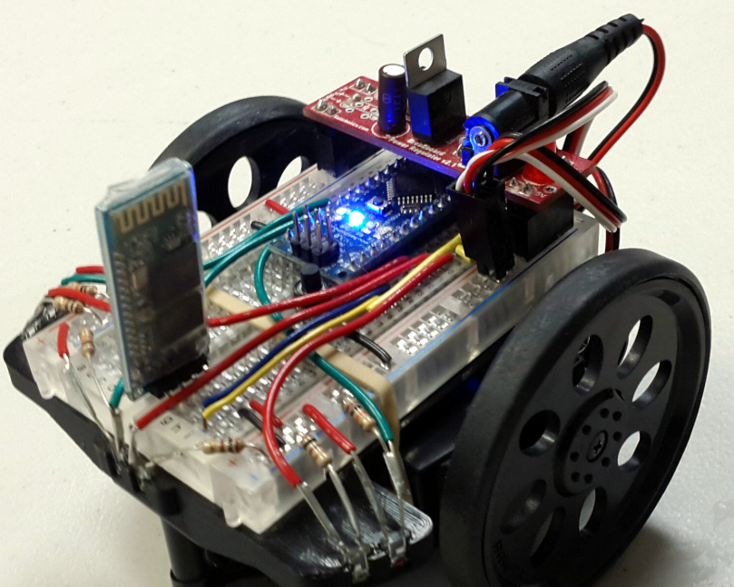
Figure 1: basic robot

Components
- Controller: Arduino Uno (large board, 8-bit, low processing speed)
- Motors: Two standard DC motors (no encoders)
- Motor Driver: L298N
- Sensors: Two simple IR sensors (one front, one side)
- Power: 9V battery
- Chassis: Acrylic base, ~12×12 cm, plastic wheels

Structure
- Basic differential drive
- Sensors placed at front corners only
- Wiring exposed and unoptimized

Size Limitation
- Larger than ideal (12×12 cm instead of ~8×8 cm) → harder to turn in tight corners.

Summary
Good for testing movement, but not accurate or efficient in a real maze

Compact but Unstable Racer (design two)
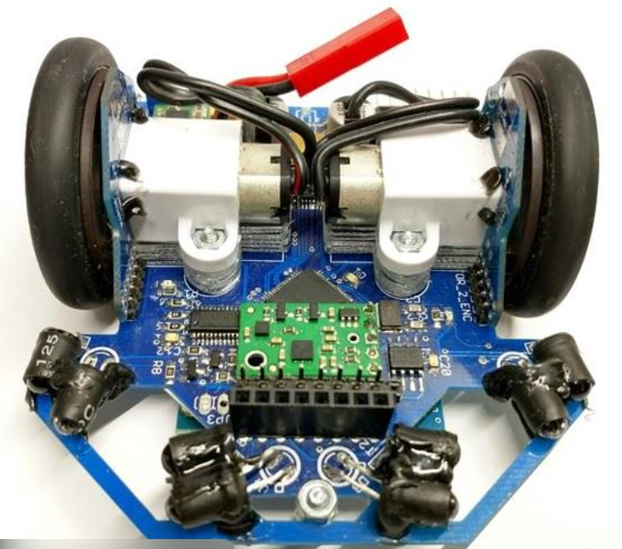
Figure 2:CBUR

Components
- Controller: STM32 or Teensy microcontroller (fast)
- Motors: High-speed DC motors with encoders
- Motor Driver: L293D
- Sensors: Only front IR sensors (for speed focus)
- Power: 2S LiPo battery
- Chassis: 3D printed, very small (~7×7 cm), lightweight

Structure
- Very small and light → high acceleration
- Few sensors (just front-facing)
- Focused on straight-line runs

Size Limitation
- Excellent compactness, but light frame causes vibration
- Small size limits battery capacity and stability

Summary
Extremely fast but unstable — great for speed demos, not reliable in full maze-solving.

design affects performance, speed, and maze-solving efficiency

- design 1
Table 1:performane of basic robot
Factor | Rating | Reason
Speed | Low | Basic motors, no speed control
Stability | Medium | Heavy 9V battery causes imbalance
Accuracy | Poor | No encoders, only 2 sensors
Maze Solving | Weak | Only follows walls; no mapping or path optimization

- design 2
Table 2:performance of CBUR
Factor | Rating | Reason
Speed | Very High | High RPM motors
Stability | Poor | Lightweight, easily slips
Accuracy | Poor | Few sensors, weak mapping
Maze Solving | Moderate | Fast but often crashes; relies on pre-mapped paths

Our Design objectives and approach
The main goal of this project was to design and model a functional Micro mouse-inspired robot using 3D printing. The robot is intended to be compact, fast, and structurally balanced, following Micromouse competition standards.
My specific design objectives were:
- Compact and Efficient Layout
To minimize size and weight, ensuring smooth navigation inside maze corridors while maintaining balance.
- Stable Two-Wheel Drive System
To achieve precise movement and turning through two front motor-driven wheels and a rear caster for support.
- Layered Structural Design
To separate electronic components (controllers, sensors, battery) across two stacked levels for better organization and heat management.
- Ease of Assembly and Maintenance
To make each part 3D-printable and easy to assemble using screws and spacers without additional tools.
- Optimal Component Placement
To position heavy components (like motors) low in the chassis for a low center of gravity, improving stability and speed.
The design process was guided by a combination of engineering analysis, CAD modeling, and Micromouse design principles:
- Research and Planning
Before modeling, I studied several Micromouse designs to understand how wheelbase, sensor placement, and weight distribution affect performance. This helped define proper dimensions and the component layout for my design.
- 3D Modeling in TinkerCAD
The robot was fully designed using TinkerCAD, chosen for its simplicity and precise control over part dimensions.
  - The bottom layer holds the DC motors, wheels, base support and sensor connections.
  - The middle layer supports the motor driver module (red board).
  - The top layer includes the microcontroller and battery holder for power distribution.
This modular, layered approach simplifies wiring and maintenance while protecting the electronic components.
- Mechanical Design Considerations
  - The wheels were positioned symmetrically for straight motion and accurate turns.
  - Spacers and support rods (blue parts) were used to maintain alignment between layers.
  - The battery holder was placed centrally on top to balance weight distribution.
  - Adequate spacing was ensured for cooling and easy access to ports.
- Performance Optimization
After assembly, component positions were adjusted to lower the center of gravity and maintain even weight balance between the two wheels. This improves traction and prevents tilting during fast turns.

Explanation of chosen design features and their purpose
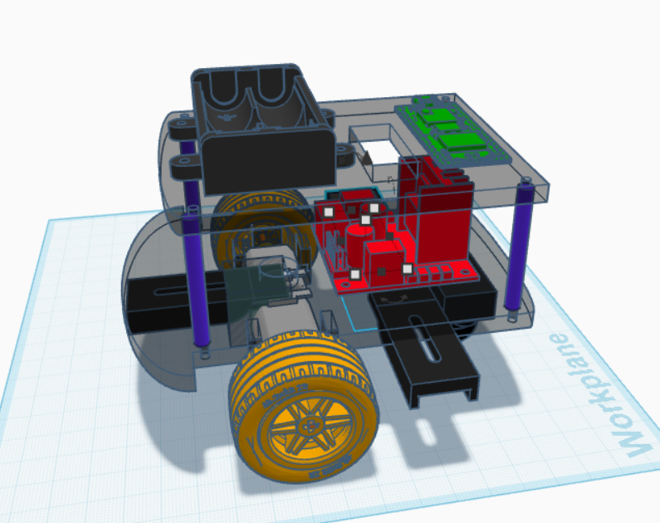
Figure 3:our design

Robot Dimensions
The designed robot is 12.5 cm long, approximately 12 cm wide, and 10 cm high. The width includes the 10 cm base platform and 1 cm for each wheel on either side. The height measurement represents the fully assembled structure, including all stacked layers and components mounted on the upper level.

All components used in the design were designed and positioned according to standard dimensions available online for each part, such as DC motors, motor actuators, infrared sensors, and the Raspberry Pi Pico board. This precise assembly, realistic proportions, and compatibility with real-world components ensure that the 3D-printed model is both functional and accurate to scale.
Comparative Analysis of Designs

When we looked at other robots, we saw two main types. The first was the "Basic Micromouse" (Design 1). It’s a good starter robot for learning, but it’s not built to compete. It uses a slow controller and doesn't have encoders, so it’s just not accurate or fast enough for a real maze.

On the other end, there was the "Compact but Unstable Racer" (Design 2). This one is all about speed. It uses fast motors and a good controller. The problem is that it's so small and light that it’s unstable and often crashes. It sacrifices reliability just to be fast.

Our design (Figure 3) is our attempt to find the perfect balance between those two. We took the good ideas from Design 2, like using a fast Raspberry Pi Pico controller and motors with encoders for accuracy. But, we learned from its mistakes. Instead of just focusing on speed, we also focused on stability. That’s why we built our 3D-printed body in layersit k eeps the heavy parts (like motors) low to the ground for a low center of gravity. We also made sure to use a full set of IR sensors with our own custom adjuster mounts for reliable wall detection.

Our goal wasn't just to make the fastest robot, but to make a robot that is reliably fast. We think our design balances speed with the stable control you actually need to solve a maze without crashing.

Summary of tools and methods used

Motor driver

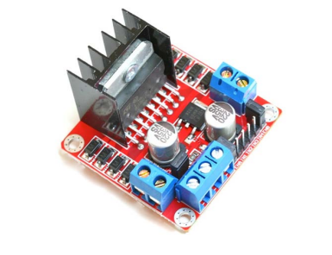
Figure 4:motor driver
- Definition: The L298N is a dual H-bridge motor driver integrated circuit that acts as an interface between the low-current Raspberry Pi Pico and the high-current DC motors. It allows the microcontroller to control the speed and direction of two DC motors independently.
- Positive Properties:
  - It can drive two DC motors bidirectionally, enabling forward and reverse rotation for each wheel.
  - It handles higher current and voltage requirements than the microcontroller can support directly, protecting the Pico from damage.
  - It allows for speed control of the motors using Pulse Width Modulation (PWM) signals from the Pico.
  - It includes protection diodes to suppress voltage spikes generated by the motors, enhancing circuit reliability.
- Function in the System: The L298N receives low-power control signals (for direction and speed) from the Raspberry Pi Pico. It then uses its internal H-bridge circuits to switch the high-power current from the battery pack to the motors. This enables the Pico to command the robot to move forward, reverse, turn left, turn right, or stop, all while isolating the sensitive electronics from the electrical noise and high current draw of the motors.

Raspberry Pi Pico Microcontroller
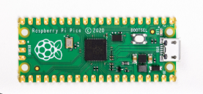
Figure 6:microcontroller
- Definition: The Raspberry Pi Pico is a low-cost, high-performance microcontroller board that acts as the robot's central brain, executing the control program.
- Positive Properties:
  - It is programmable in MicroPython, which simplifies coding complex logic.
  - It features a dual-core ARM processor, allowing it to handle multiple tasks simultaneously.
  - Its Programmable I/O (PIO) blocks are ideal for managing precise sensor data and motor control signals.
  - It offers a large number of GPIO pins to connect all sensors and actuators.
- Function in the System: The Pico runs the main control algorithm. It continuously reads data from the IR sensors and encoders, processes this information to make navigation decisions, and sends command signals to the DC motors to steer and move the robot through the maze

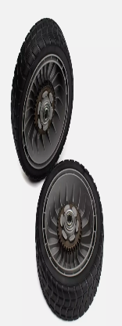
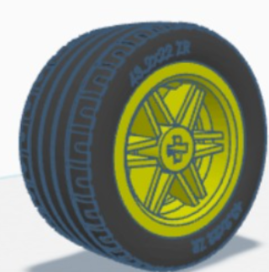
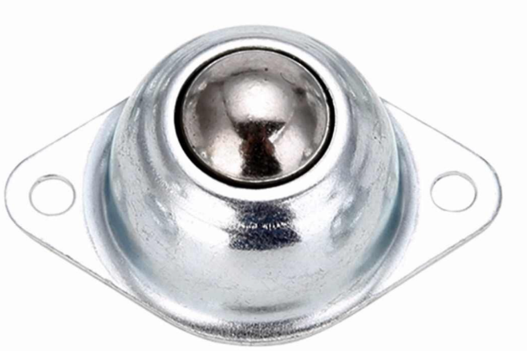
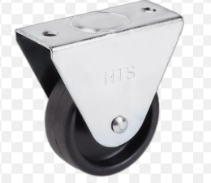
Wheel System (2 Drive Wheels, 1 Caster Wheel)
Figure 8: Drive Wheels
Figure 7:caster wheel
- Definition: This is a differential drive system consisting of two independently driven main wheels for propulsion and steering, and one free-rolling caster wheel for balance.
- Positive Properties:
- The differential drive design provides exceptional maneuverability, enabling the robot to pivot in place and make tight turns.
- The caster wheel provides a third point of contact, ensuring static stability and balance.
- It is a simple, robust, and effective mechanical design for small robots.
- Function in the System: The two main wheels, placed on the central axis, are responsible for all movement. By spinning these wheels at different speeds or in opposite directions, the robot can drive forward, reverse, and turn. The caster wheel at the front swivels freely to support this motion without resisting it.

IR Sensor (Infrared Sensor)
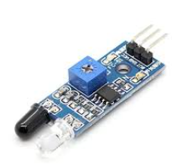
Figure 9:IR sensor
- Definition: An IR sensor is an electronic device that measures the distance to an object by emitting infrared light and detecting the intensity of the light reflected back from the surface.
- Positive Properties:
- It provides non-contact distance measurement, preventing collision with surroundings.
- It is low-cost, simple to use, and has a fast response time.
- It has a fast response time and can accurately detect short-range distances, ideal for small robots.
- It is compact, lightweight, and consumes minimal power, making it suitable for mobile, battery-operated systems.
- Function in the System: The IR sensors are mounted on the front of the robot and are used to calculate the distance between the robot and nearby maze walls. By measuring the amount of reflected infrared light, the microcontroller can estimate how far the robot is from a wall. This real-time distance data helps the robot maintain a consistent gap from the maze walls, and avoid collisions.

IR Sensor Adjuster

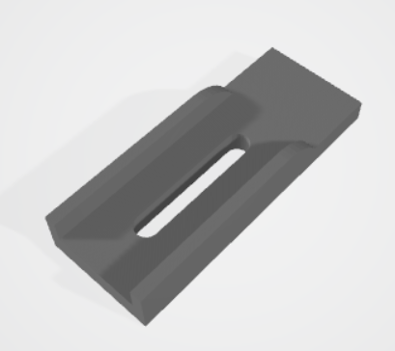
Figure 10:adjuster
- Definition: This is a custom 3D-printed mechanical bracket that allows for the physical adjustment of the IR sensors' height and angle.
- Positive Properties:
  - It allows for precise calibration and tuning of the sensors for optimal performance under different lighting and surface conditions.
  - It compensates for manufacturing tolerances and assembly errors, ensuring sensors are perfectly aligned.
  - It facilitates experimentation to find the ideal sensing distance.
- Function in the System: The adjuster is a critical design feature that ensures reliability. It allows the user to fine-tune the sensor position after assembly, guaranteeing the best possible line-following accuracy without needing to reprint or modify the main robot chassis.

DC Motor with encoder
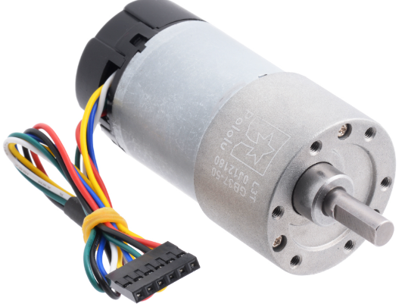
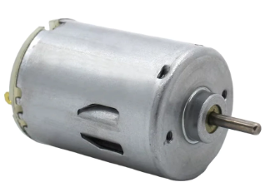
Figure 11:DC motor
- Definition:A DC motor is an actuator that converts direct current electrical energy from the battery into rotational mechanical energy.
- Positive Properties:
  - It provides high torque at low speeds, which is necessary to move the robot.
  - Its speed can be easily controlled using a technique called Pulse Width Modulation (PWM).
  - It is reversible, allowing for forward and backward movement.
- Function in the System: The DC motors serve as the robot's “muscles.” They are connected to the main wheels and, upon receiving commands from the microcontroller (via the motor driver), they generate the torque needed to propel the robot. Each motor is also paired with a rotary encoder, which measures the motor shaft’s rotation. This feedback allows the system to calculate the wheel’s speed and distance traveled, enabling precise movement control. By continuously comparing the encoder data with the desired motion, the microcontroller can adjust motor speed or direction in real time, ensuring accurate navigation and smooth turns within the maze.

Power Box (Battery Holder)
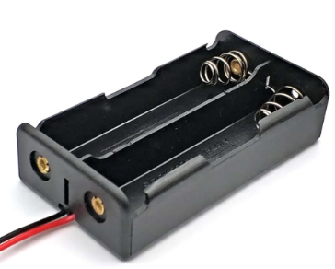
Figure 12:power box
- Definition: The power box is a housing unit that contains the batteries, providing a centralized and stable power source for all electronic components.
- Positive Properties:
- It organizes and secures the power source, making battery replacement easy.
- It protects the batteries and connections from accidental disconnection.
- It provides a stable voltage supply to the system.
- Function in the System: It powers the Pico, sensors, and motors. Using a dedicated battery holder is crucial for safety and helps prevent power-related issues, such as voltage drops that could reset the microcontroller.

Breadboard

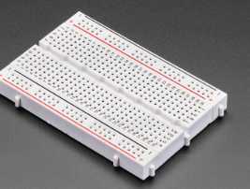
Figure 13:Breadboard
- Definition: A breadboard is a solderless prototyping platform used to build and test electronic circuits temporarily.
- Positive Properties:
  - It enables rapid prototyping and easy modification of circuits without soldering.
  - It is reusable and helps in keeping wiring organized and logical.
  - It simplifies the process of debugging the circuit.
- Function in the System: The breadboard is used to host the Raspberry Pi Pico and create all the necessary electrical connections between the microcontroller, sensors, motor driver, and power supply. It is the central hub for the robot's electronics during the prototyping phase.
Note: we use it for testing before assembling electronic parts with 3D printed parts.

Justification for Chosen Components
Each of the selected components in our Micromouse-inspired robot was carefully chosen based on their cost-effectiveness, ease of use, compatibility, and performance relative to alternative options. The goal was to balance functionality and simplicity while ensuring all parts could be integrated smoothly for a reliable prototype.
We chose the Raspberry Pi Pico microcontroller primarily because it supports MicroPython, which makes coding and debugging significantly easier compared to other boards like the Arduino Uno that rely on C/C++. The Pico’s dual-core ARM Cortex-M0+ processor, rich GPIO set, and low power consumption make it powerful enough for handling motor control, sensor input, and navigation logic simultaneously. Additionally, it is more affordable and compact than alternatives such as the Arduino Mega or ESP32, making it ideal for a lightweight maze robot.
The L298N motor driver was selected because of its simplicity, reliability, and ability to handle two DC motors simultaneously. While more modern drivers like the L293D or TB6612FNG offer slightly higher efficiency, the L298N provides built-in protection diodes and easy wiring, making it a better educational and prototyping choice. Its robust design also tolerates minor voltage fluctuations and wiring errors, which is important for early-stage testing.

The DC motors with encoder were chosen instead of stepper motors because they offer higher speed and lower power consumption, which are better suited for fast maze navigation. With encoder use of measuring distance the robot travels, in case of controlling its movement and right/left turning.
The IR sensors were chosen for their accuracy, compact size, and efficiency in short-range distance measurement. They are highly effective for detecting nearby walls and obstacles, allowing the robot to maintain the correct spacing within maze corridors. Compared to alternatives like ultrasonic or LiDAR sensors, IR sensors offer faster response times, less signal noise, simpler integration, and lower power consumption, making them ideal for a lightweight, battery-powered robot.
Finally, components like the breadboard, battery holder, and IR sensor adjuster were included to simplify prototyping and calibration. The breadboard enables quick and flexible circuit testing without soldering, while the adjustable sensor mounts allow fine-tuning of sensor angles for optimal performance.
In summary, these specific components were selected to provide a balanced combination of affordability, ease of use, and performance ideal for a Micromouse-style educational robot that emphasizes both functionality and learnability.

Conclusion
Through this project, a complete Micromouse robot design was successfully developed using 3D modeling and analysis techniques. The design process—from research to CAD modeling—highlighted the importance of weight balance, compactness, and sensor arrangement in achieving smooth and precise movement within maze environments.
The final model meets Micromouse competition standards, providing enough space for essential components such as motors, sensors, controller, and battery, while maintaining a lightweight structure suitable for high-speed turns.
Compared to other designs, the proposed robot achieves a better trade-off between performance and stability, making it well-suited for efficient maze-solving. Overall, this project demonstrates how engineering design, creativity, and 3D printing technology can be combined to produce an optimized and realistic robotic prototype ready for further development and testing.

References
[1] Thingiverse – A platform for sharing and downloading 3D printable designs.
Available at: https://www.thingiverse.com/
[2] Printables – A community-driven website for 3D models and design inspiration.
Available at: https://www.printables.com/
[3] GrabCAD – A library of CAD models and engineering resources used for mechanical design reference.
Available at: https://www.grabcad.com/
[4] Additionally, we utilized AI tools to assist in structuring sentences, improving technical writing clarity, and generating creative design ideas, ensuring the report was well-organized and professionally written.

